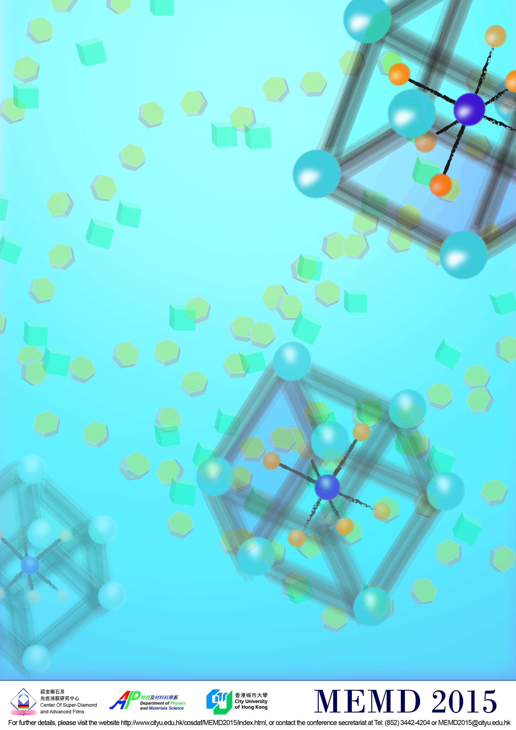
Registration Form for Student
International Conference on Molecular Electronic Materials and Devices │MEMD2015
International Conference
on Molecular Electronic Materials and Devices
5-8 January 2015 | City University of Hong Kong, Hong Kong
MEMD2015
Please return until 30 November 2014 | via fax to +852 3442 0541  or email: memd2015@cityu.edu.hk
Center of Super-Diamond and Advanced Films (COSDAF)  City University of Hong Kong  Tat Chee Avenue, Kowloon Tong, Hong Kong | phone: +852 3442 4204
Name

Suffix

Institution

Department

Address

Country

Email

Phone
Please book for me the following social events (costs will NOT be covered by organizers, accompanying person will pay on site):
^{person(s)}
^{person(s)}
We accept payments in both HK and US dollars by bank draft and direct transfer. Please contact Conference Secretariat for further information. But payments by MasterCard / VISA will be charged in HK Dollars only. All payments are non-refundable.
Please charge to:
Cardholder Name: EXPIRY DATE (DD/YYYY)
Card No.: Validation Number (3-digit):
Total Payment HKD2,400 (in USD300) + HKD (for social event) Signature: _______________________
Conference Registration:
We will arrange your registration. A confirmation will be send to you by email.

Date: Signature:

