Conference Report (SGS13R)
Notes:
- This conference report should be completed and submitted to the Chow Yei Ching School of Graduate Studies within two months from the end date of the conference.
- Reimbursement of the conference expenses will be processed upon the presentation of documents required in Section A.6 and will be made directly to the student’s bank account as listed in the Scholarship and Financial Aid under AIMS. For students who have not provided their bank account information before or would like to change their bank account for receiving Scholarship/Financial Aid payments, please fill in a “Scholarship and Financial Aid - Bank Account Information Form” (obtainable at SGS) and attach the completed form to this Conference Report.

Section A (To be completed by the Awardee) (* Please delete as appropriate)
1. | Personal Particulars
 | Name: |  |  |  | Student No.:
 | School/Department: |  |  | Programme: |  |  |  |  | Mode of Study:
 | Contact Phone No.: |  |  | Source of Funding:
 | Are you a Hong Kong PhD Fellowship (HKPF) recipient? Yes No
 | Are you a Presidential PhD Scholarship (PPS) recipient? Yes No

2. | Reimbursement of Expenses Incurred
 | Item |  |  | Expenses Incurred |  | For FO Use
 |  |  |  | Currency | Amount | SGS’s  Conf. grant | Travel allowance@
 | a. | Cost of  (for overseas conference only)
 | b. | Conference registration fee
 | c. | Subsistence allowance  (for overseas conferences only, and not applicable if an air ticket-hotel package was purchased)  ( night(s), for the period of  - ) | SGS’s Conf. grant  ($300/night,  up to $1,000)
 | c. |  | Travel Allowance@  ($1,000/night)
 | Total amount:
@ Applicable to Hong Kong PhD Fellowship recipient only

3. | Conference Details
 | Date of Conference: From |  |  | to
 | Title of Conference:
 | Title of the paper:

4. | Seminar Presentation
 | According to the condition for the award of the grant, I have delivered a seminar in the School/Department, with details as follows:
 | Date of Presentation:
 | Topic:

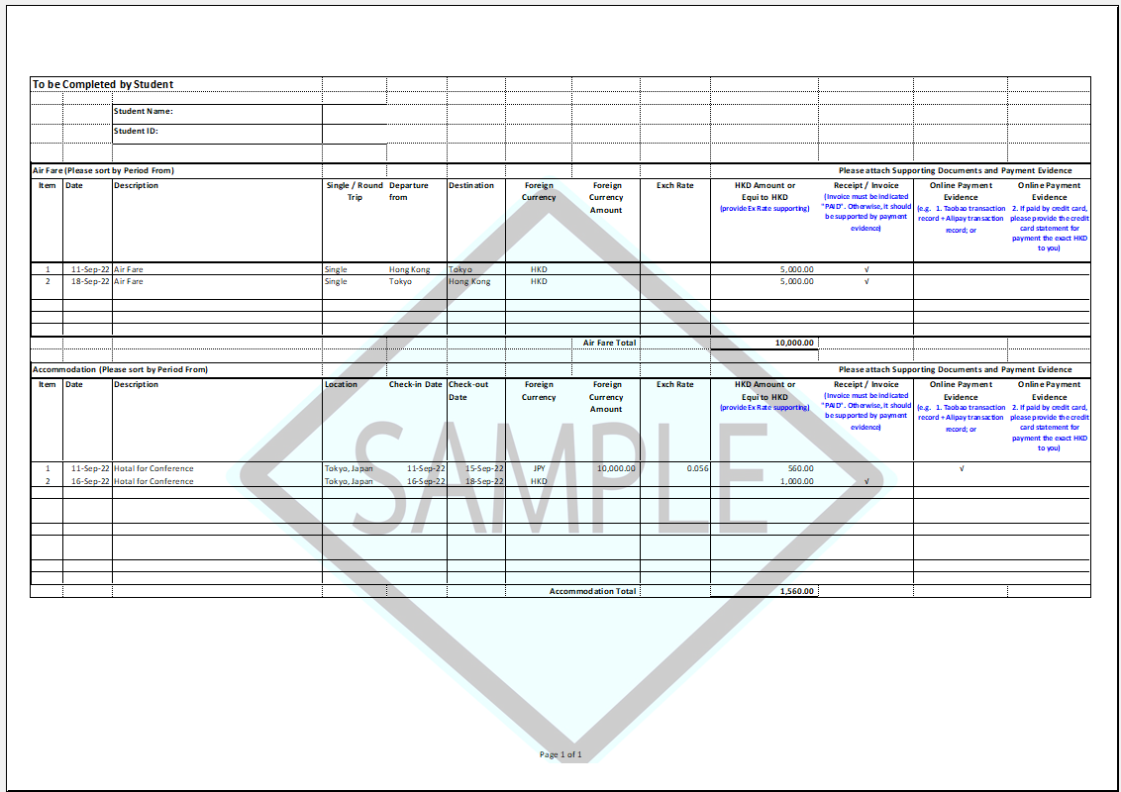
To be Completed by Student
 |  | Student Name:
 |  | Student ID:
Air Fare (Please sort by Period From) |  |  |  |  |  |  | Please attach Supporting Documents and Payment Evidence
Item | Date | Description | Single / Round Trip | Departure from | Destination | Foreign Currency |  | Foreign Currency Amount | Exch Rate | HKD Amount or  Equi to HKD  (provide Ex Rate supporting) | Receipt / Invoice  (Invoice must be indicated "PAID". Otherwise, it should be supported by payment evidence) | Online Payment Evidence  (e.g. 1. Taobao transaction record + Alipay transaction record; or | Online Payment Evidence  2. If paid by credit card, please provide the credit card statement for payment the exact HKD to you)
1
2
 |  |  |  |  |  |  |  | Air Fare Total

Accommodation (Please sort by Period From) |  |  |  |  |  |  | Please attach Supporting Documents and Payment Evidence
Item | Date | Description | Location | Check-in Date | Check-out Date | Foreign Currency |  | Foreign Currency Amount | Exch Rate | HKD Amount or  Equi to HKD  (provide Ex Rate supporting) | Receipt / Invoice  (Invoice must be indicated "PAID". Otherwise, it should be supported by payment evidence) | Online Payment Evidence  (e.g. 1. Taobao transaction record + Alipay transaction record; or | Online Payment Evidence  2. If paid by credit card, please provide the credit card statement for payment the exact HKD to you)
1
2
 |  |  |  |  |  |  |  | Accommodation Total |  | -

5. | Conference Report
 | Please give a brief assessment on the value and the usefulness of the conference to your research (not less than 200 words) (use separate sheets if necessary):

6. | List of Supporting Document(s) Required
Please attach the following document(s) to facilitate our processing. Applications with incomplete supporting document(s) will not be processed. Document(s) submitted are not returnable:

- A copy of the approval on conference grant
- Copies of conference information:
- paper(s) presented at the conference; and
- conference programme.
- Original receipts for:
- the cost of one return passage and the itinerary by the most economical means available or air ticket-hotel package;
- boarding passes;
- conference registration fee; and
- accommodation expenses for the period of the conference.

 | Signature: |  | Date:

Section B (To be completed by the Supervisor)
For supervisors who will provide support on the expenses in attending conference using their research projects, it is recommended to attach relevant documents (e.g. Memo to FO) together with this form, if available, to facilitate FO’s processing.

I confirm that the student has delivered a seminar in the School/Department as stated in Section A.4.
Other comments, if any:
Name of Supervisor |  | Signature |  | Date

Please forward this form to Chow Yei Ching School of Graduate Studies for processing.

For internal use only □ Membership release
To: FO
The student has fulfilled the requirements for claiming the financial support. Please check the receipts attached and arrange for reimbursement through:
Checked by
 | CO | EO
Name
Ext.
Date

Provider | SFAID(s) | Appr. Amt (HK$)
Provider | SFAID(s) | Original | Revised
□ SGS | □ 397 (UGC) □ 767 (non-UGC)
□ Col/Sch/Dept | □ 861 (non-UGC)
□ Supervisor | □ 859 (UGC-related) □ 860 (External)
□ HKPFS | □ #610 (Travel Allowance)\
□ 1411 (HKPFS Additional Conference and Research Related Allowance)
Poster Conference: HK$4,000 per conference
Oral Conference: HK$8,000 per conference
Prestigious Conference Award: HK$10,000 per conference
□ PPS | □ 1435 (Assistantship for Conference Grant)
# Please exhaust funding from Travel Allowance first.
* For institutional-funded students, the 1st grant is to be funded by SGS and the 2nd by Col/Sch/Dept/Supervisor.
N:\SGS Forms\SGS13R_Conference Report (Nov 2022)

